1. Write a script called mycase, using the case utility to checks the type of character entered by a user:
a. Upper Case.
b. Lower Case.
c. Number.
d. Nothing.
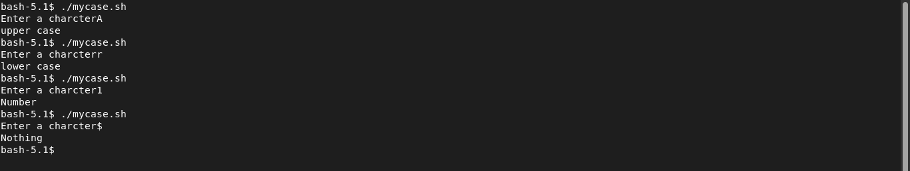
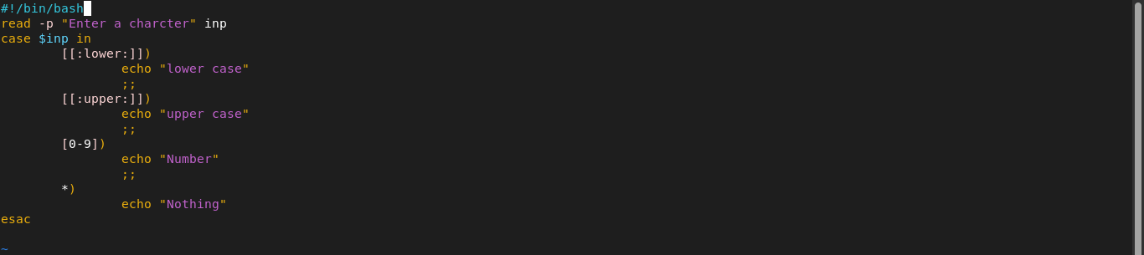

2. Enhanced the previous script, by checking the type of string entered by a user:
a. Upper Cases.
b. Lower Cases.
c. Numbers.
d. Mix.
e. Nothing.

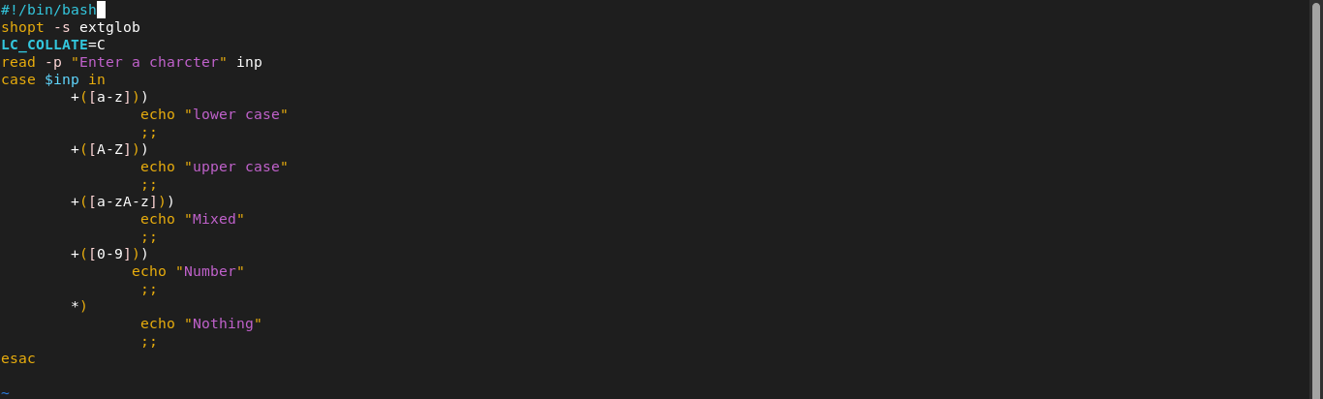
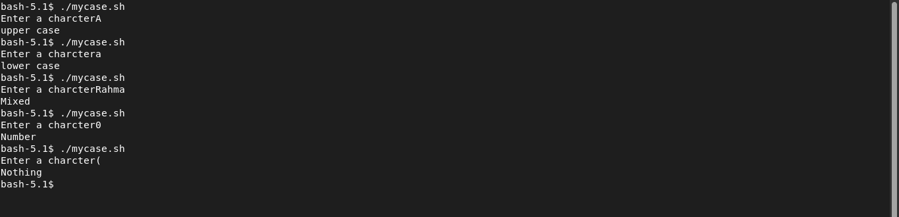
3. Write a script called mychmod using for utility to give execute permission to all files and directories in your home directory.
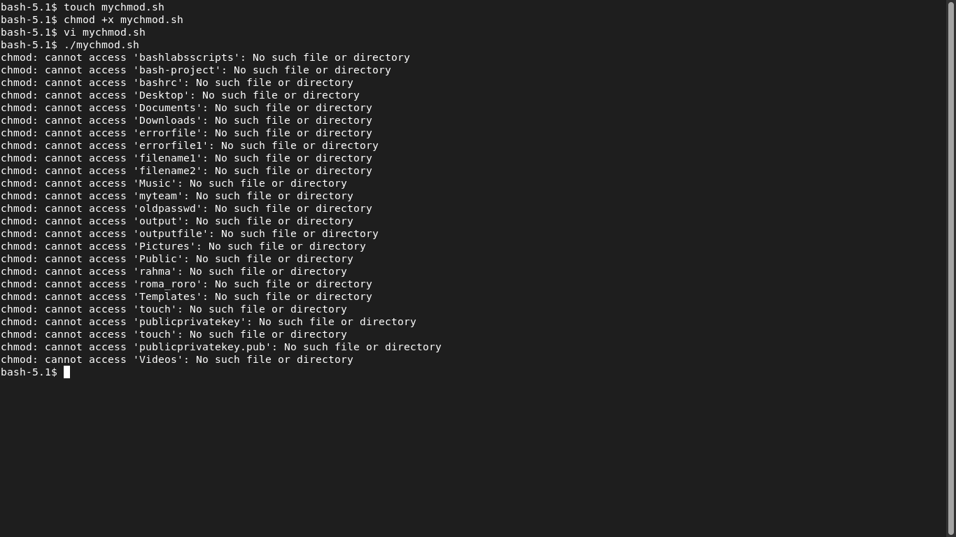

4. Write a script called mybackup using for utility to create a backup of only files in your home directory.

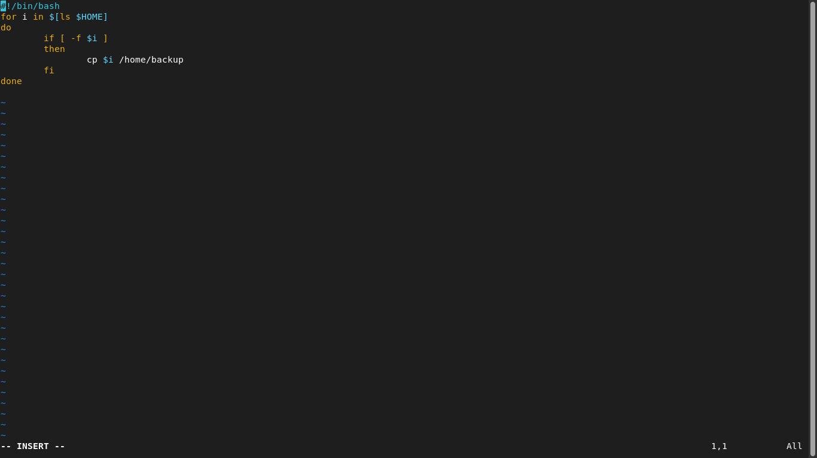
5. Write a script called mymail using for utility to send a mail to all users in the system. Note: write the mail body in a file called mtemplate.

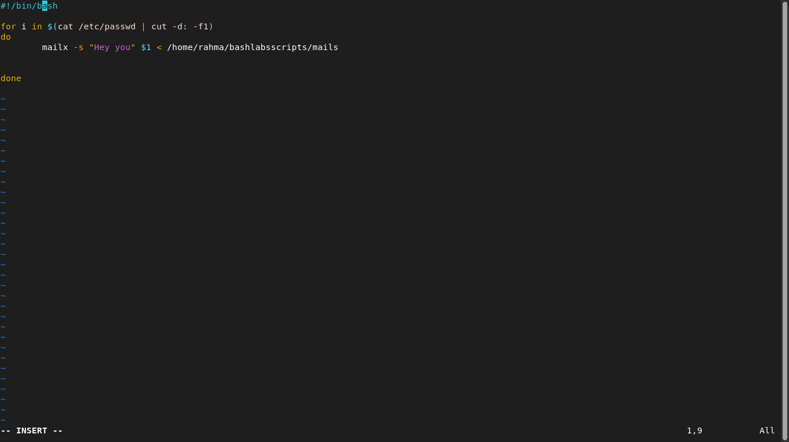

6. Write a script called chkmail to check for new mails every 10 seconds. Note: mails are saved in /var/mail/username.
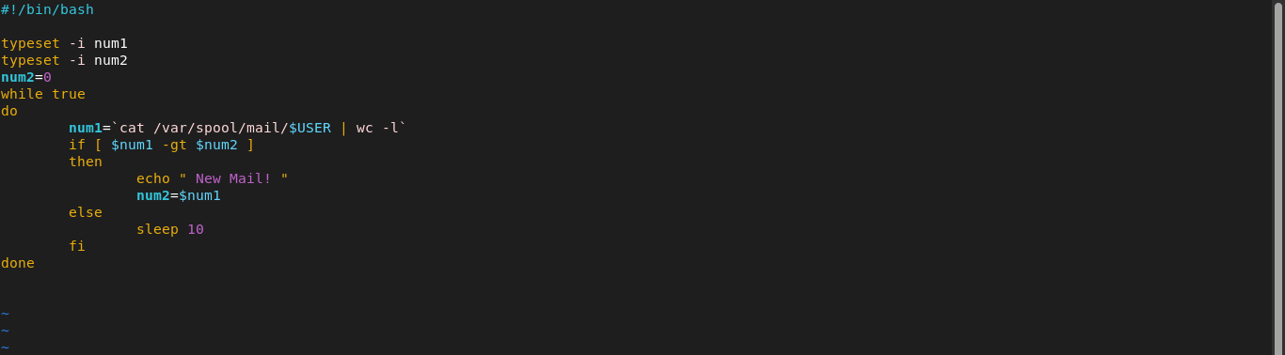

7. Tracing the script result

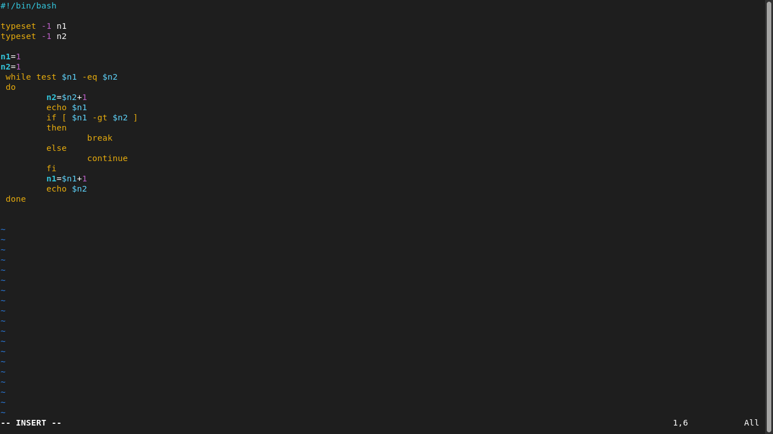
8. Create the following menu:
a. Press 1 to ls
b. Press 2 to ls –a
c. Press 3 to exit
Using select utility then while utility.

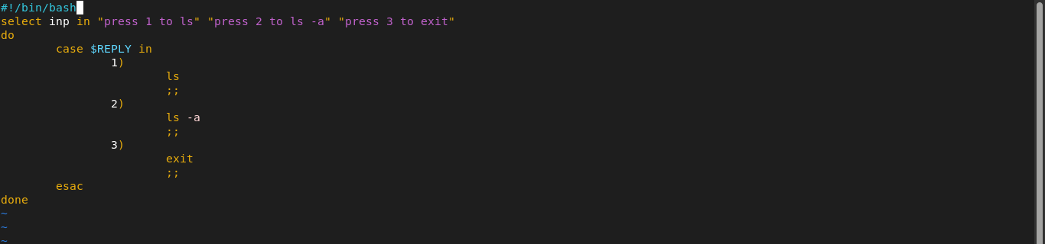
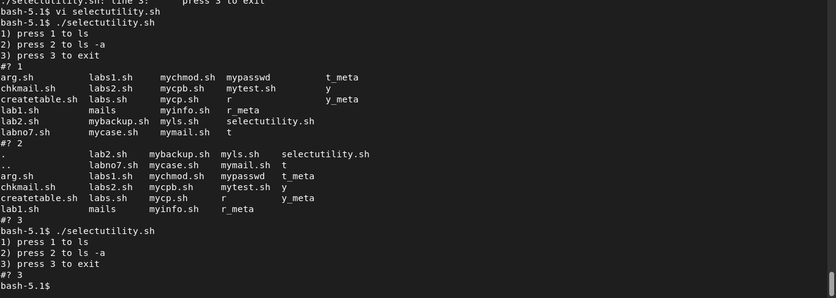
9. Write a script called myarr that asks the user how many elements he wants to enter in an array, fill the array and then print it.

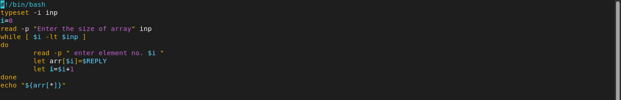
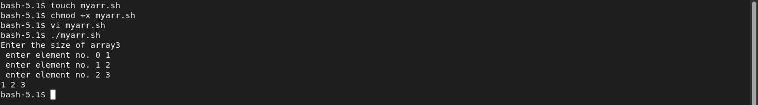

10. Write a script called myavg that calculate average of all numbers entered by a user. (Note: use arrays)

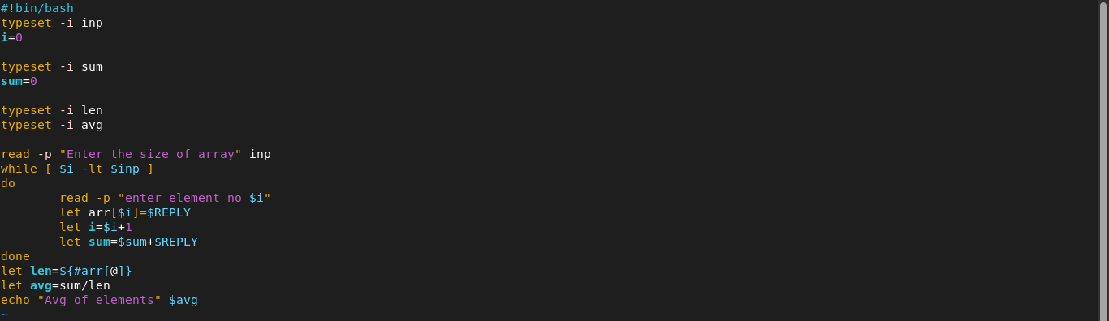

11. Write a function called mysq that calculate square of its argument.

